Supplementary files
Supplementary file 1. List of chemicals for oxidative stress determination.
- Methanol (pro analysis, min 99.8%) was obtained from MOSS (Belgrade, Serbia).
- Bovine serum albumin (BSA) was purchased from Human GmbH (Wiesbaden, Germany).
- L-Glutatione reduced, (−)-epinephrine, sodium dodecyl sulfate (SDS) and 5,5′-dithiobis (2-nitrobenzoic acid) (DTNB) were purchased from Sigma-Aldrich Chemie GmbH (Darmstadt, Germany).
- 2-Thiobarbituric acid (TBA) was obtained from ABCR GmbH (Karlsruhe, Germany).
- 1,1,3,3-Tetraethoxypropane (malonaldehyde-bis(diethyl acetal), MDA) was purchased from Acros Organics (Geel, Belgium).

Supplementary Table 1. List of primers used for RT PCR analysis.
 | Foward | Reverse
β-actin | AAGATCCTGACCGAGCGTGG | CAGCACTGTGTTGGCATAGAGG
Bax | CGGCGAATTGGAGATGAACTGG | CTAGCAAAGTAGAAGAGGGCAACC
Bcl-2 | TGTGGATGACTGACTACCTGAACC | CAGCCAGGAGAAATCAAACAGAGG

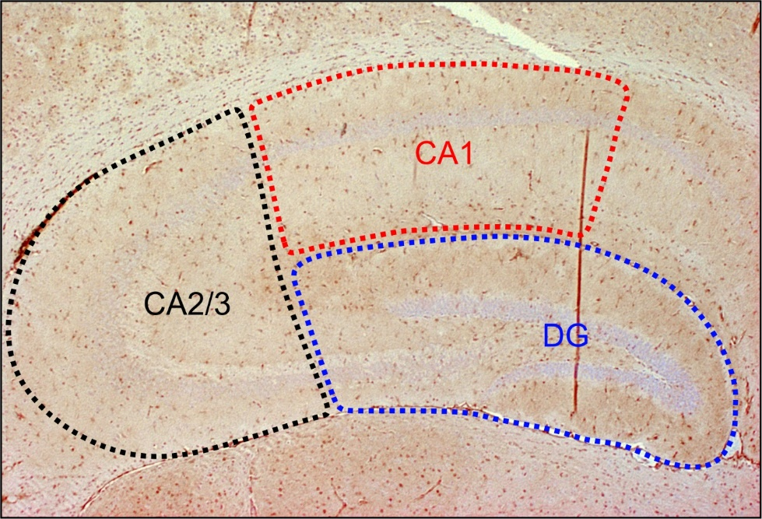
Supplementary Fig. 1. Strategy for immunohistochemical analysis of hippocampal regions.

